# 01 MAR 2021

“less aggressive movement”

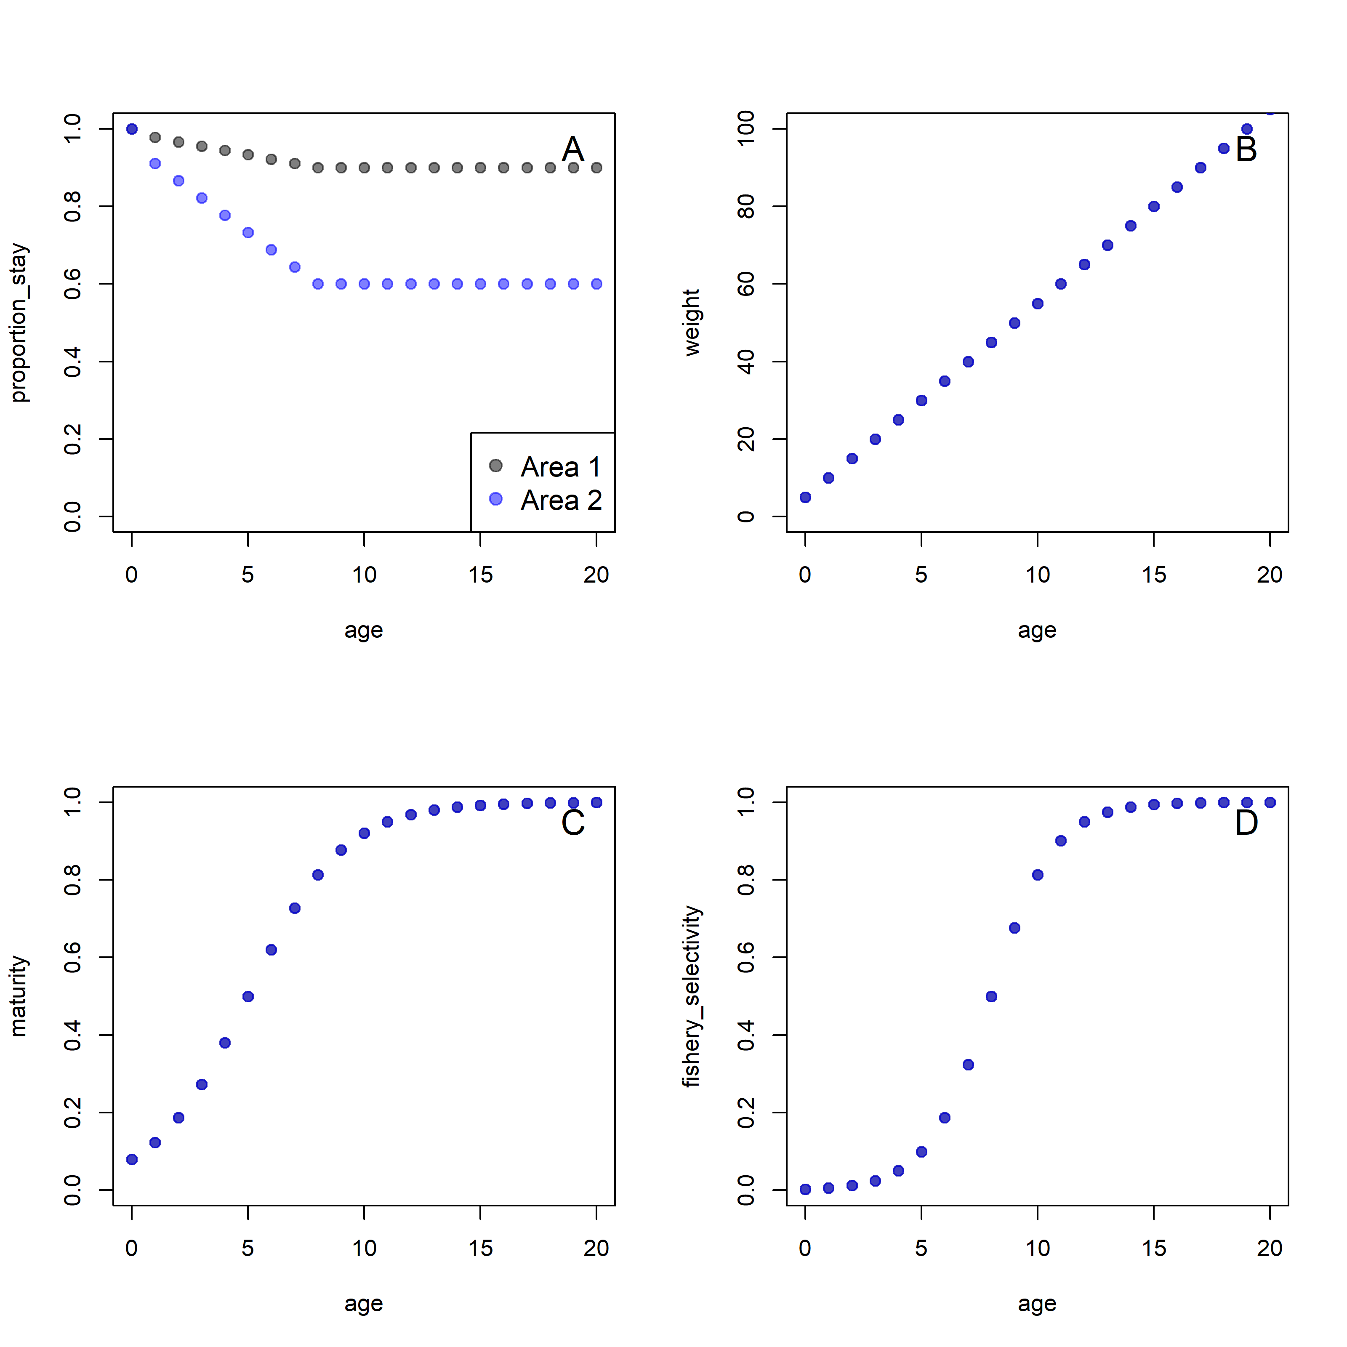

Figure X. Data input into simulation with movement only. In all plots, grey dots correspond to values used in area 1; blue dots correspond to values used in Area 2. A) Proportion of individuals at age which stay in their source area; there is no movement of age-0 recruits among areas; B) weight at age; C) maturity at age; S) fishery selectivity at age.

Figure X. Data input into simulation with movement and higher selectivity in area 1. In all plots, grey dots correspond to values used in area 1; blue dots correspond to values used in Area 2. A) Proportion of individuals at age which stay in their source area; there is no movement of age-0 recruits among areas; B) weight at age; C) maturity at age; S) fishery selectivity at age.

Figure X. Data input into simulation with movement and lower selectivity in area 1. In all plots, grey dots correspond to values used in area 1; blue dots correspond to values used in Area 2. A) Proportion of individuals at age which stay in their source area; there is no movement of age-0 recruits among areas; B) weight at age; C) maturity at age; S) fishery selectivity at age.

Figure X. Data input into simulation with symmetrical movement at adult ages. In all plots, grey dots correspond to values used in area 1; blue dots correspond to values used in Area 2. A) Proportion of individuals at age which stay in their source area; there is no movement of age-0 recruits among areas; B) weight at age; C) maturity at age; S) fishery selectivity at age.

Figure X. **Movement only scenario.** Total yield versus given *F* levels in Area 1 and 2 (colored tiles). LHS: proposed method, where calculations are made after optimizing R_bar and R_prop to most closely mimic the global input. Points are the MSY (where non-negative) for combinations of F. RHS: global method, where the SRR is calculated by applying the beverton-holt to the global input R0 and proportion. In this scenario, the proposed method returns higher MSY at lower FMSY.

Figure X. **Movement + higher selectivity in A1 scenario.** Total yield versus given *F* levels in Area 1 and 2 (colored tiles). LHS: proposed method, where calculations are made after optimizing R_bar and R_prop to most closely mimic the global input. Points are the MSY (where non-negative) for combinations of F. RHS: global method, where the SRR is calculated by applying the beverton-holt to the global input R0 and proportion. In this scenario, the proposed method returns higher MSY at lower FMSY.

Figure X. **Movement + lower selectivity in A1 scenario.** Total yield versus given *F* levels in Area 1 and 2 (colored tiles). LHS: proposed method, where calculations are made after optimizing R_bar and R_prop to most closely mimic the global input. Points are the MSY (where non-negative) for combinations of F. RHS: global method, where the SRR is calculated by applying the beverton-holt to the global input R0 and proportion. In this scenario, the proposed method returns a lower FMSY with near-equal yields.

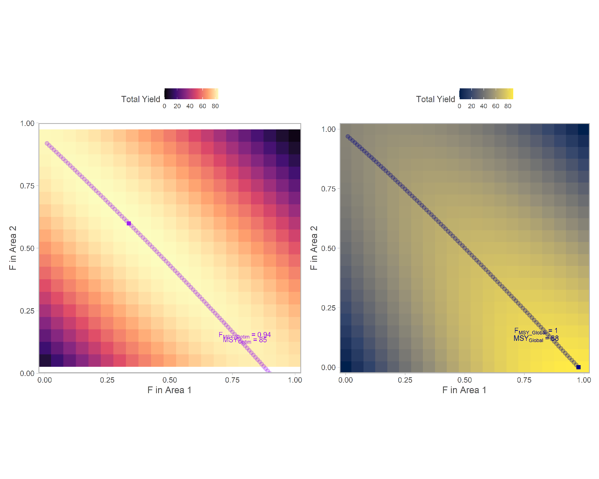

Figure X. **Symmetrical movement for adults scenario.** Total yield versus given *F* levels in Area 1 and 2 (colored tiles). LHS: proposed method, where calculations are made after optimizing R_bar and R_prop to most closely mimic the global input. Points are the MSY (where non-negative) for combinations of F. RHS: global method, where the SRR is calculated by applying the beverton-holt to the global input R0 and proportion. In this scenario, the proposed method returns a lower FMSY with higher MSY.

# 11 FEB 2021

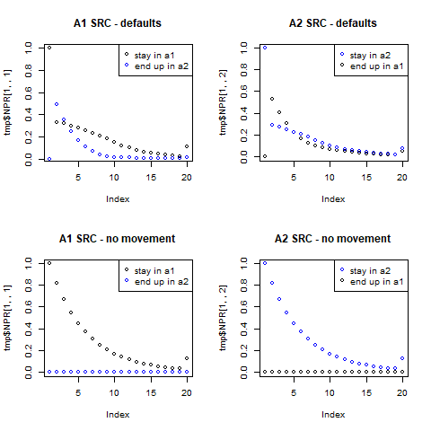

Figure X. Validating population dynamics. The top row illustrates the fate in numbers-at-age of individuals spawned in area 1 (left column) or spawned in area 2 (right column); the area they reside in at age is given by point colors (grey = in area 1, blue = in area 2). The bottom row indicates expected behavior in the absence of movement; no individuals spawned in A1 (bottom left) end up in Area 2, and vice versa.

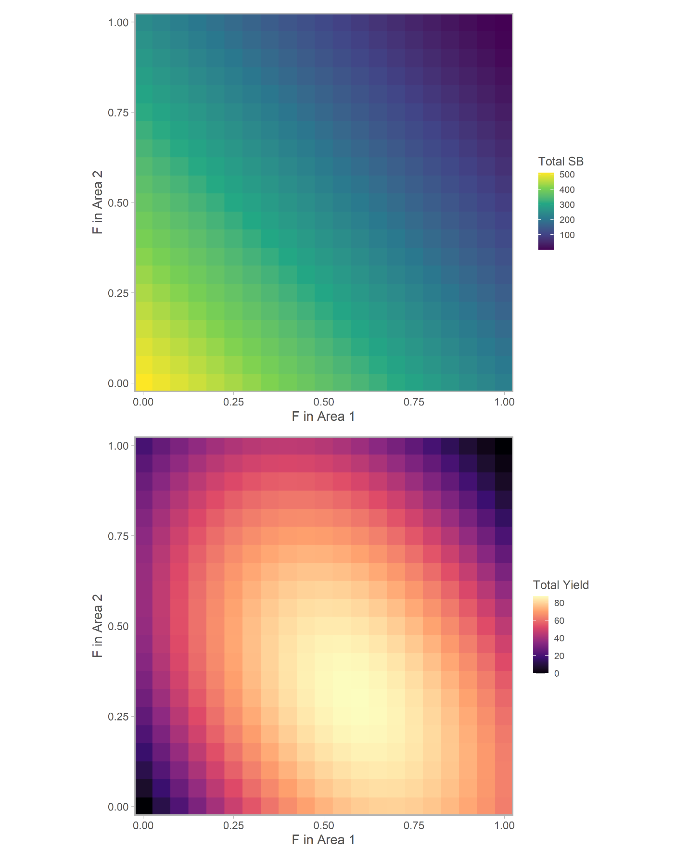

Figure X. Total SSB (top panel) and total yield (bottom panel) given *F* levels in Area 1 and 2. These calculations are made after optimizing R_bar and R_prop to most closely mimic the global input.

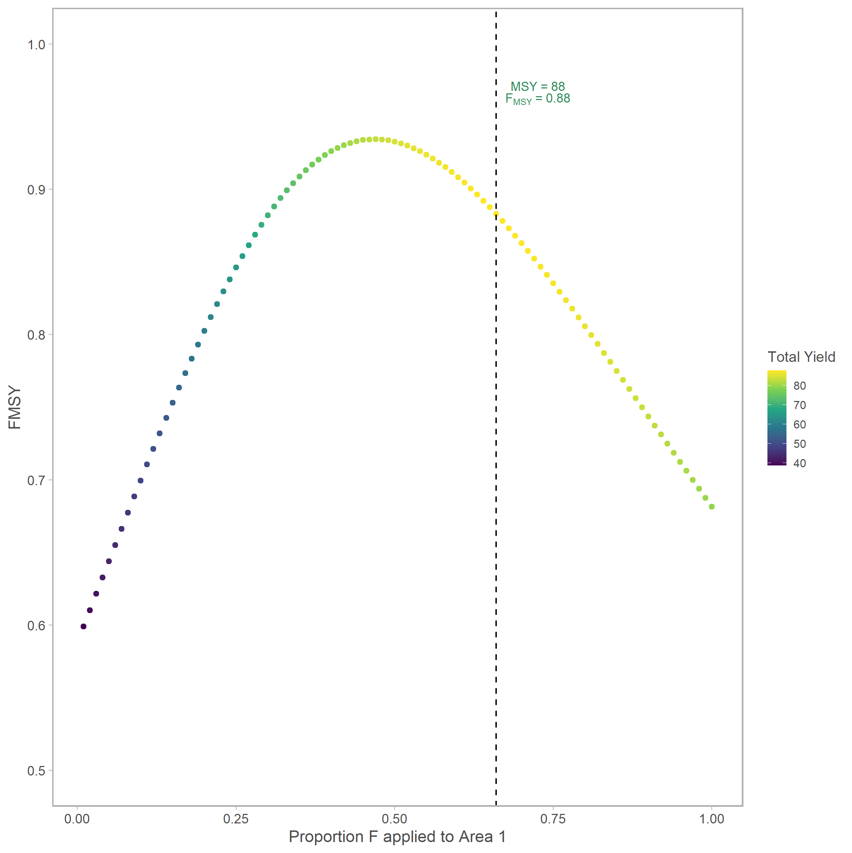

Figure X. System-wide FMSY, given proportion F applied to area 1. The color of the points indicate the total yield obtained by each strategy. This is calculated by finding the optimum F given apportionment to Area 1.

The reason for the banding is that each value of FMSY corresponds to a diagonal cross section of the heatmap shown above, i.e. there are many values of FA2 and FA1 which sum to FMSY, and the variation in yield is determined by the proportion of that total which is applied in each. You can picture this as a diagonal line of varying slope cutting across the figure; when it passes through the “hot” part of high yield, the slope is about 2/3 or 0.6.

**Other figures we might want**

* Comparison between global and this method
* Something regarding estimated rbar, rprop

**Addl analyses**

* Spectrum of movement rates
* Varied slx